Bash Scripting Assignment-02
1.Create a bash script to check if a directory is available or not.
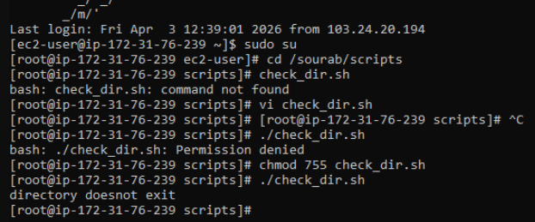
2. Create a bash script to create multiple files.
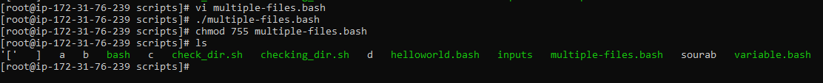

3. Create a bash script to take a backup of a directory.
4. Create a bash script to install Nginx on an EC2 server.
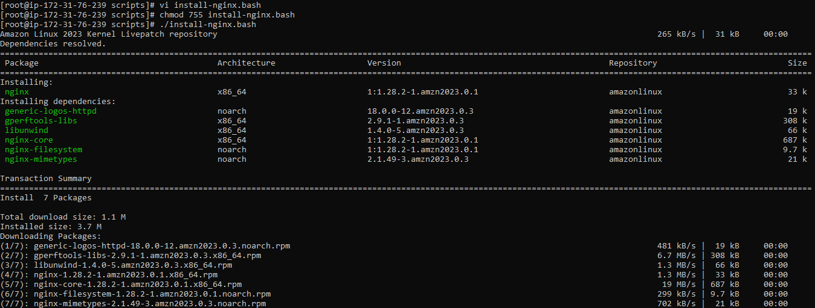
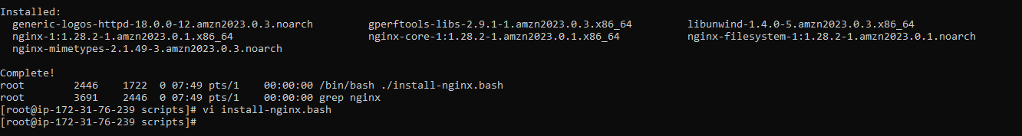

5. Create a bash script to install Apache Tomcat on an EC2 server.
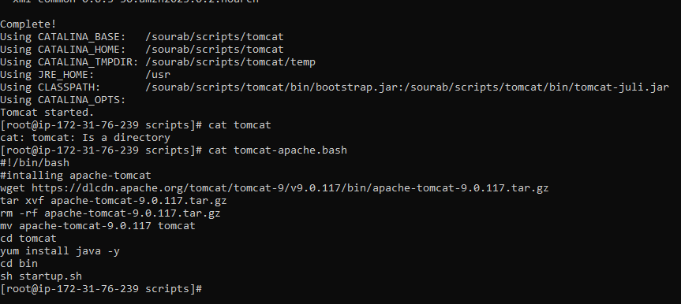
6. Create a bash script to check if the Nginx service is running, if not
running then script should start the service.
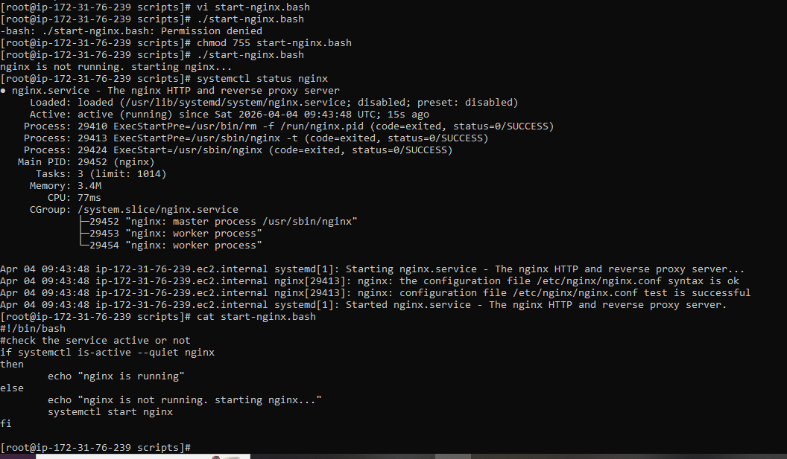

7. Create a bash script for a calculator.
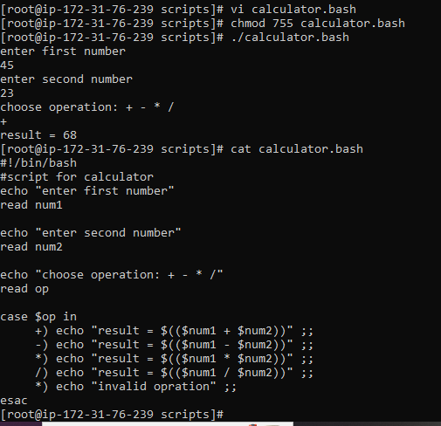

8. Create a bash script to check if a directory exists, if not then create a directory
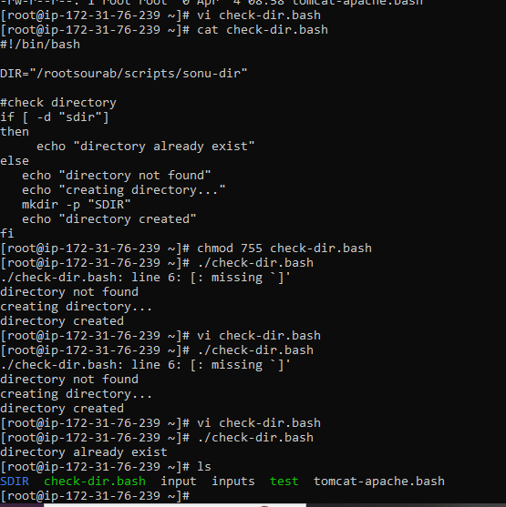
9. Create a bash script to delete the last 3 lines of a file.
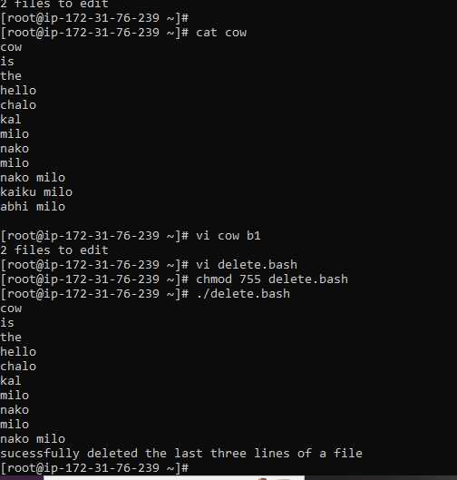

10. Bash script to monitor cpu and if it is more than 50% then send email
notification.
first we have to install mailx service and do some configuration on
/etc/mail.rc file
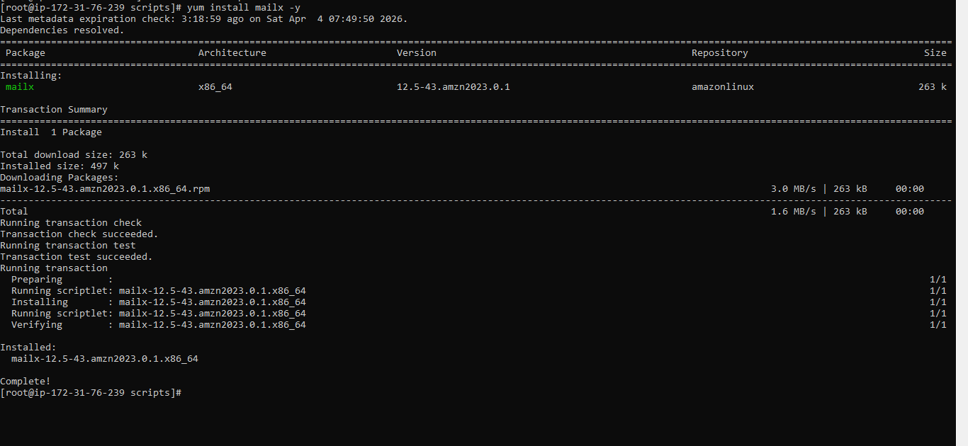

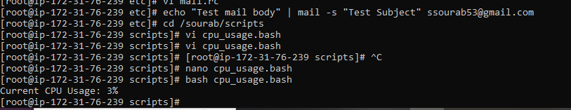
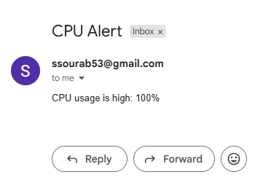
11. Bash script to monitor disk space and if it is more than 20% then
send email notification
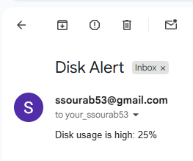
12. Bash script to monitor memory and if it is more than 30% then send
email notification.
